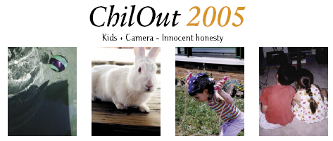

Purchase a ChilOut Calendar for 2005
All profits from the sale of these calendars will go to assist children and their parents or carers in Australian immigration detention centres. Please help these families by purchasing calendars for your home and work, friends and family.

Order Form
 | Qty |  | Price | Total
ChilOut Calendar 2004 |  |  | $12.00 ea
Package & Postage per calendar |  |  | $1.50 ea
All prices inclusive of GST | Total incl. GST:
Name:
Postal Address:
Phone number: | (Day) (Evening)
Email Address:
Please make cheque or money order payable to: Friends of Children in Detention.

Post orders to: |  | Friends of Children in Detention  PO BOX 811  Neutral Bay, NSW 2089
Order enquiries: Please email Jane store@chilout.org

To purchase calendars by credit card through our on-line store please visit our website www.chilout.org and follow the link to the ChilOut Store.

