Christmas Islanders raised over $3000 to help Hao Kiet boatpeople

[Media release CÑNVTD/UC 25/6/04] On Saturday 19th June, a fundraising dinner organised by a group of Australians on Christmas Island was a huge success, raising over $3000 for the legal appeal fund for our Hao Kiet people detained at the Immigration Detention Centre on the island. It shows the support of islanders towards boatpeople.

Considering that the whole island population is only about 1000, the organisers planned to sell 40-60 tickets, but a few days before the event, all tickets were sold out. On the night, 86 people attended.

Lisa Nicholson, one of the main organisers, told us that "The huge success of this event was due to the hard work of many volunteers working in the evenings and on weekends. The people who attended really enjoyed the event, and many others who could not attend made donations.” Lisa Nicholson is also a belly dancer, she provided one of the entertainment numbers for the evening theme “1001 Nights Freedom Feast” with a belly dance (see photo)

Lin Gaff, another of the chief organisers, said “Much of the fresh vegetables used in the menu had been grown and donated by the Hao Kiet people at the Detention Centre. Usually we have a weekly flight that delivers fresh produce to the island, but there was no flight this week. Luckily, the Hao Kiet boatpeople grow vegetables at the detention centre. They certainly are diligent people who won’t live in idleness.”

Photo 1 - Part of the crowd attending the evening

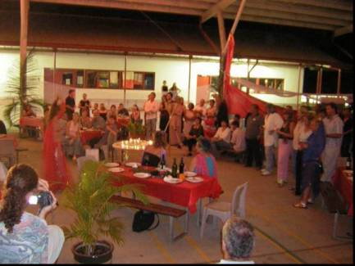
Photo 2 – Lisa Nicholson’s belly dance

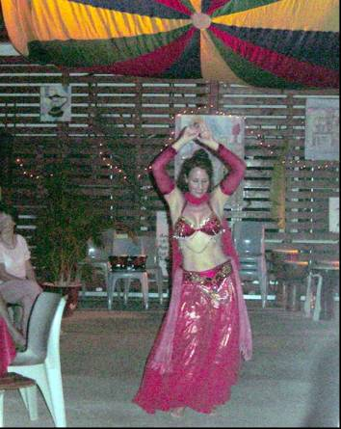

Photo 3 - Lin Gaff holding a sign showing the thank-yous of a group of boatpeople. Lin says "I send my love and hope to all Vietnamese asylum seekers"

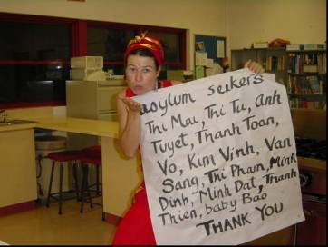

Photo 4 - A group of organisers doing the cooking

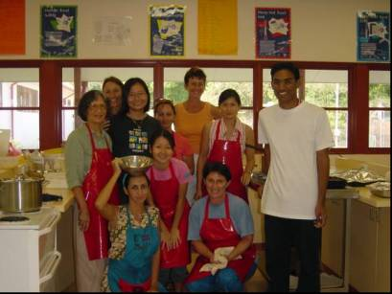

Photo 5 - Each guest lit a candle in a dedication to all refugees. The wish which all the volunteers shared was that “the Hao Kiet people can have their freedom to start a new life in Australia as free citizens."

