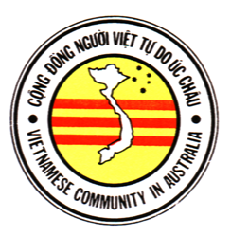C¶ng ñÒng NgÜ©i ViŒt T¿ Do Úc Châu
Vietnamese Community in Australia
PO Box 606 Cabramatta NSW 2166

Tel: 0500 88 88 00 Email: cdnvtduc@hotmail.com

MEDIA RELEASE 27 May 2005
“[T]he family can of course go back to Vietnam at any time”
No, Prime Minister Howard,
these Vietnamese asylum seekers cannot

According to yesterday’s media reports, the Prime Minister said the above in relation to the Vietnamese asylum seekers who are parents of baby Michael Andrew Tran.

No, they cannot go back. They have been involved in an organised operation of dropping pro-democracy leaflets in Vietnam. This is considered by Hanoi’s kangaroo courts a crime against the state, and subject to long imprisonment. Some 15 others in their group, who came with them to Australia in July 2003 on the same boat, have already been given refugee status by the Refugee Review Tribunal.

The Hanoi regime’s ruthless will to kill and imprison dissidents is well documented. As reported by Human Rights Watch, last Easter it killed dozens, perhaps hundreds, of Montagnards involved in a peaceful land-rights demonstration. And despite a few recent releases, the regime is still keeping hundreds of prisoners of conscience in prison.

- Mr. Minh Dat Tran and Mrs. Hoai Thu Nguyen named their son Michael Andrew Tran because they learned that “Michael rowed to the shore”, and because they are grateful to Democrats Senator Andrew Bartlett who had visited the group on Christmas Island, showing much genuine concern for the unnecessarily harsh treatment that they received under the current mandatory detention regime.

Enquiries:
Mr. Trung Doan, Federal General Secretary, 0400 466 848

