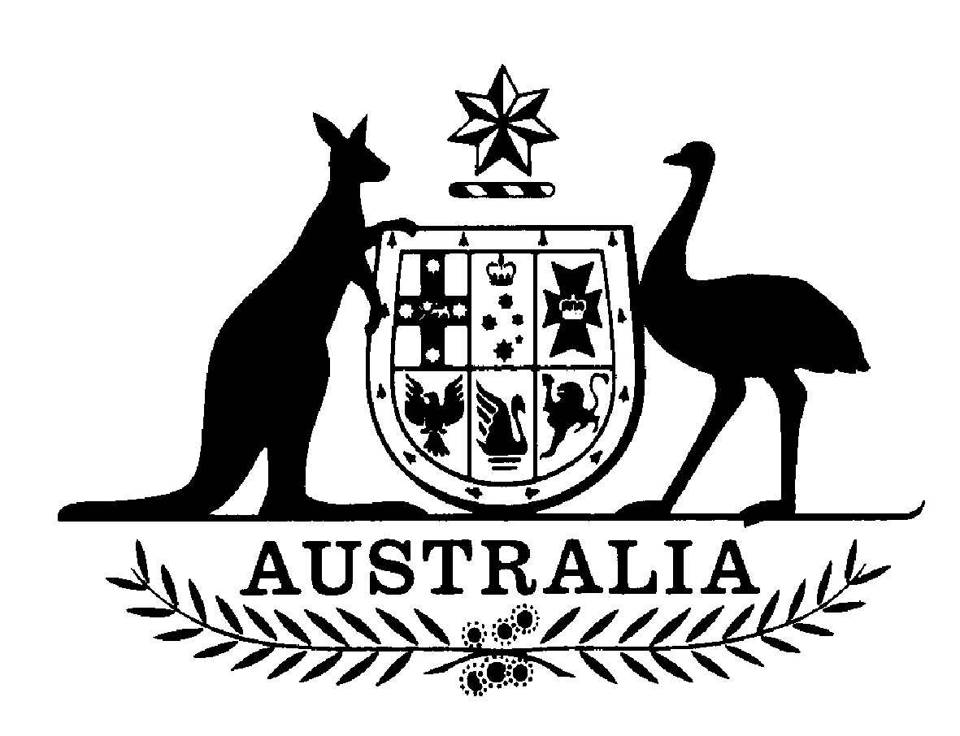
World Refugee Day – a day of shame for Australia
TANYA PLIBERSEK MP
FEDERAL MEMBER FOR SYDNEY
18 June 2004

The theme for this year’s World Refugee Day, “A place to call home: Rebuilding lives in safety and dignity”, should serve as a timely reminder of the plight of refugees and asylum seekers fleeing persecution all around the world.

Tanya Plibersek MP, Member for Sydney, said, “We as a society must show compassion to those seeking asylum in our community. The immense determination and courage of asylum seekers fleeing oppressive regimes is not something to be ignored.”

“Instead of providing refugees with a place to call home and a chance to rebuild their lives, the Howard government throws compassion and humanity out the window by incarcerating them indefinitely,” said Ms Plibersek. “There is something seriously wrong with a government that keeps asylum seekers in detention for anything up to 5 years.”

Ms Plibersek went onto say, “The recent HREOC report of its National Inquiry into Children in Detention, slams the government and its policy of mandatory detention, particularly in locking up children, and is a clear indication that the government’s demonising attitude towards refugees and asylum seekers. The government must drastically change its policy to bring it into line with Australia’s international obligations.”

Ms Plibersek concluded by saying, “A Labor government will treat asylum seekers and refugees living in our community with the dignity and respect they deserve. We will ensure they have adequate access to health care, income support, education (including English language classes) and employment services.”

Tanya will be speaking at the World Refugee Day rally this Sunday 20th June 1pm, Hyde Park North.

