MEDIA RELEASE
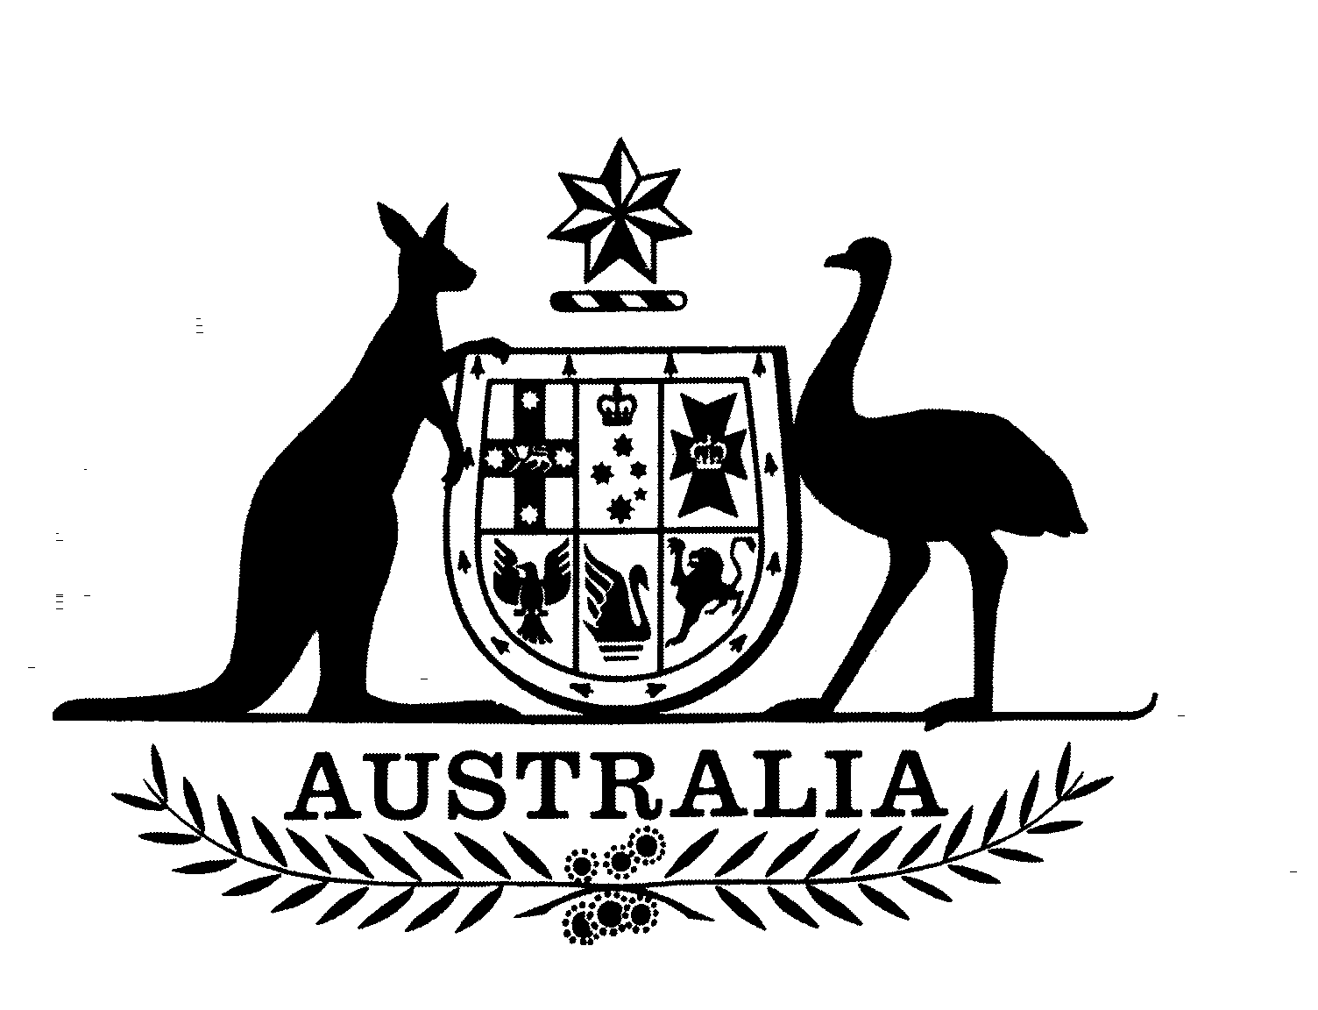
Stephen Smith MP
Shadow Minister for Immigration
Member for Perth

21/04 May 2004

HOWARD GOVERNMENT SLAMMED BY HREOC FOR CHILDREN IN DETENTION POLICY AND ADMINISTRATION

The Human Rights and Equal Opportunity Commission’s (HREOC) report into Children in Detention is an indictment of the Howard Government’s children in immigration detention policy and an indictment of its administration of that policy.

The Government has presided over a bad period here. The Government should simply acknowledge that its policy and administration has been a mistake and set the system up for the future so that this cannot happen again.

If the Government does not do this, on coming to office Labor will.

Labor has had the absolute commitment since 2002 that immigration detention centres are no place for children. I again call on the Howard Government to remove all children from these facilities. I note that the HREOC report again highlights the capacity of the Minister to release a child from immigration detention at any time.

HREOC has condemned the Government for presiding over an immigration detention regime where the welfare, safety and health of a child is not the primary concern. HREOC has underlined the common sense view that the long term immigration detention of children is not in the best interests of children or in the public interest.

The Report found that there were inadequate guidelines in dealing with children in detention facilities between the Government and the private manager of the centres, Australasian Correctional Management (ACM).

This underlines Labor’s point that the management of immigration detention centres should not be privatised or outsourced to overseas countries, international corporations or private companies, but should be a matter for Commonwealth officers on Commonwealth territory.

The Commission also found that due to the lack of procedural guidance and suitable resources, children were often placed at risk including during times of violence.

Other findings highlight the inadequacy of facilities and resources for children with disabilities. One case cited in the Report is of a child severely disabled with cerebral palsy who was not placed in alternative detention while the case for asylum was assessed over a 3 year period.

Labor agrees with the HREOC recommendation that the Minister for Immigration should not be the guardian of an unaccompanied child in immigration detention.

Labor has a commitment to establish a Federal Children’s Commissioner and believes the guardianship of an unaccompanied child seeking asylum in Australia would be an ideal role for the Children’s Commissioner.

Labor also shares HREOC’s concern that despite the extensive consideration of mainland immigration detention facilities, the conditions and facilities for children in Nauru remain unscrutinised.

There are approximately 80 children in immigration detention in Nauru. This is more than the total of all other detention centres put together.

Yet the Howard Government continues its on going denial of Commonwealth responsibility for the so called ‘Pacific Solution’. It would not allow HREOC to include Nauru in their investigation.

The Government cannot continue to deny responsibility for Australia’s immigration detention centres in Nauru and Manus Island. Labor remains committed to ending the so called ‘Pacific Solution’.

Labor will now consider all the findings and recommendations of the Commission’s Report in detail.

Labor is committed to changing the system so that this cannot happen again.

Contact: Courtney Hoogen on (02) 6277 4108 or 0414 364 651

